**AMERICAN INTERNATIONAL UNIVERSITY BANGLADESH**

**INTRODUCTION TO DATABASE**

**SECTION: I**

**Final project**

**TOPIC NAME: UNIVERSITY MANAGEMENT**

**NAME & ID:**

**SHIHABUN SAKIBA JANNAT (20-41992-1)**

**BADHAN AKTER (20-42225-1)**

**SNAHASISH DEY (20-42237-1)**

**BUSHRA, TAZIN JANNAT (20-42797-1)**

**RAFI REZA HUQ (20-43360-1)**

**CONTENTS**

**SECNARIO**

**ER DIAGRAM**

**NORMALIZATION**

**TABLE CREATION**

**PRIMARY KEY, FOREIGN KEY**

**VALUE INSERT**

**CONSTRAINTS**

**SEQUENCE**

**QUERY WRITING**

**SCENARIO**

**UNIVERSITY MANAGEMENT**

AIUB university has many students who study here. Every student has their own id, name, City and Country . Also every teacher has their id, name, salary, Address and Phone number.   
Teachers teach students by Department wise. Every Department has their own teachers and student also. Department has Id, name and Number of course. And every course must related with their own department. Admin-management pay salary of them. They have also id, name ,age and phone number. Employees are pay from Admin. Every employee has their own id, name , salary, join date, address. Employees are maintained by department. Every student take section for complete their courses. Section has its own id, name, number of section and capacity of student. Students studies many courses and teachers takes many courses. Course has also Id, name, validation date. Student can read books for study. Every book has its own id , number, publish date and writer name.

**Er diagram**

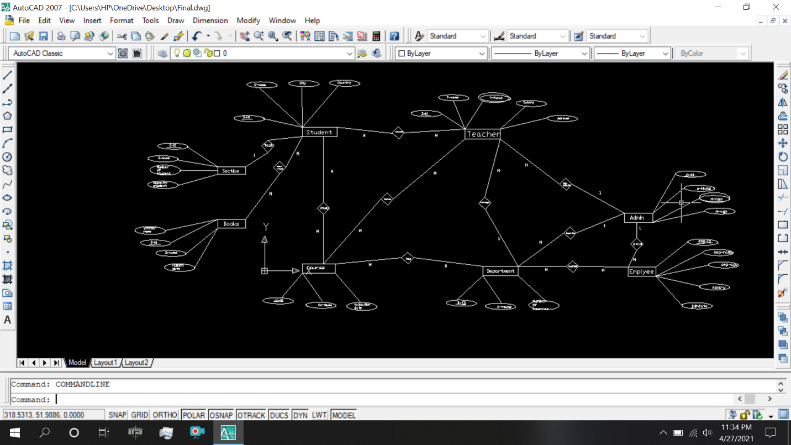

**NORMALIZATION**

**For Relation 1** : Teaches (S_id, S_Name, Country, City, T_id, T-Name, T_P-Number, Salary, Address)

1NF: Phone Number is a multi valued attribute.

2NF:S_id, S_name, Country, City

T_id, T_name, , T_P-Number, Salary, Address  
3NF: S_id, S_Name,

C_id, Country, City

T_id, T_Name, T_P-Number, Salary, Address

Final Table: 1)S_id,S_Name,(C_id)

2)C_id, Country, City

3)T_id, T_name, Salary, Address

4) T_P-Number,T_id

5)S_id, T_id, N_id

**For relation 2**: PaySalary (T_id, T_name, Salary ,T_P-Number, Address , A_id, A_name, Age, A_P-number)

1NF: Phone Number is a Multi valued attribute

2NF: T_id, T_name, Salary, T_P-Number, Address

A_id, A_name, Age, A_P-Number

3NF:Non-transitive Dependency

T_id, T_name, Salary, T_P-Number, Address

A_id, A_name, Age, A_P-Number

Final Table: 1)T _id,T_name,Salary,Address,(A_id)

2)A_id,A_Name, Age

3) T_P-Number, T_id

4) A_P-Number, A_id

**For Relation 3**: Pays(A_id, A_Name, A_P-Number, Age,Emp_id, Emp_name, Salary, Address, joindate)

1NF:Phone Number is a multi valued attribute

2NF: A_id, A_Name, A_P-Number, Age

Emp_id, Emp_name, Salary, Address, joindate

3NF:Non-transitive Dependency

A_id, A_Name, A_P-Number, Age

Emp_id, Emp_name, Salary, Address, joindate

Final Table: 1) A_id, A_Name, Age

2) Emp_id, Emp_name, Salary, Address, joindate, A_id

3) A_P-Number, A_id

**For Relation 4** :Takes (S_id,S_name,Country, City, Se_id, Se_name, number of section, capacity of student)

1NF:No multi valued attribute.

2NF: S_id,S_name, Country, City

Se_id,Se_Name , number of section , capacity of student

3NF:S_id,S_Name,C_id

C_id, Country, City

Se_id, Se_Name, number of section, capacity of student

Final Table: 1)S_id,S_name,(C_ID),(Se_id)

2)C_ID, Country, City

3)Se_id,Se_Name, number of section, capacity of student

**For Relation 5** :Studies(S_id, S_name, Country, City, Co_id, Co_name, validation-date )

1NF:No multi valued attribute.

2NF:S_id,S_name, Country, City

Co_id,Co_name, validation-date  
3NF:S_id,S_Name

C_id, Country, City

Co_id, Co_name, validation-date

Final Table: 1)S_id,S_name,(C_ID)

2)C_ID, Country, City

3)Co_id,Co_name, validation-date

4)J_id,(S_id),(Co_id)

**For Relation 6** :Takes(T_id,T_name,Salary,T_P-Number, Address, Co_id,Co-name, validation-date)

1NF: Phone Numer is a multi valued attribute

2NF:T_id,T_name,salary,T_P-Number, Address

Co_id,Co_name, validation-date

3NF:Non-Transitive dependancy

T_id, T_name, salary, T_P-Number, Address

Co_id, Co_name, validation-date

Final Table: 1)T_id,T_name,salary, Address

2)Co_id,Co_name,validation-date

3)K_id,(T_id),(Co_id)

4) T_P-Number, T_id

**For Relation 7**: Manage(T_id,T-name,T_P-number,salary,Address ,D_id,D_name,Number of course)

1NF:Phone Number is a Multi valued attribute.

2NF:T_id,T_name,Salary,T_P-Number, Address

D_id,D_name,Number of Course  
3NF:Non-Transitive Dependency

T_id,T_name,Salary,T_P-Number, Address

D_id,D_name,Number of Course

Final Table: 1)T_id,T_name,Salary,Address, (D_id)

2)D_id,D_name,Number of course

3) T_P-Number,T_id

**For Relation 8** :Has(Co_id,Co_name,validation-date, D_id,D-name,Number of course)

1NF:No multi valued attribute

2NF:Co_id,Co_name, validation-date

D_id, D_name, number of course  
3NF:Non-Transitive Dependency

Co_id,Co_name,co_validationdate

D_id, D_name, number of course

Final Table: 1)Co_id, Co_name, validation-date, (D_id)

2)D_id,D_name,Number of course

**For Relation 9** :Supervise (A_id,A_Name,Age,A_P-number, D_id,D-name,Number of course)

1NF:phone number is a multi valued attribute

2NF:A_id,A_Name,Age,A_P-number

D_id,D_name,number of course  
3NF:Non-Transitive Dependency

Final Table: 1)A_id,A_Name,Age

2)D_id,D_name,number of course ,(A_id)

3) A_P-number, A_id

**For Relation 10** :Maintain (D_id,D-name,Number of course, Emp_ID,Emp_Name, salary, joindate, Address )

1NF:No multi valued attribute

2NF:D_id,D_name,number of course

Emp_ID,Emp_Name, salary, joindate, Address   
  
3NF:Non-Transitive Dependency

D_id,D_name,number of course

Emp_ID,Emp_Name, salary, joindate, Address

Final Table: 1)D_id,D_name,Number of course

2)Emp_ID,Emp_Name,salary, joindate,Address

3)L_id, D_id, Emp_id

**For Relation 11** :can-read (S_id, S_name, Country, City, B_id, B_name,writer-name, publish_date)

1NF:No multi valued attribute.

2NF:S_id,S_name, Country, City

B_id, B_name,writer-name, publish_date

3NF:S_id,S_Name,

C_id, Country, City

B_id, B_name,writer-name, publish_date)

Final Table: 1)S_id, S_Name, (C_id)

2)C_id, Country, City

3)B_id, B_name,writer-name, publish_date  
 4)P_id, S_id, B_id

*FINAL TABLE LIST:*

1)C_id, Country, City ->location

2) T_PNumber,T_id->contact

3)(S_id, T_id,) N_id->new tbl

4)T _id,T_name,Salary, Address,(A_id)->Teacher

5)A_id,A_Name, Age->admin

6) A_P-Number, A_id->contact2

7) Emp_id, Emp_name, Salary, Address, joindate,( A_id)->employee

8)S_id,S_name,(C_ID),(Se_id)->Student

9)Se_id,Se_Name, number of section, capacity of student->Section

10)J_id,(S_id),(Co_id)->Roll

11)K_id,(T_id),(Co_id)->Serial

12)T_id,T_name,Salary,Address (D_id)->teacher2

13)Co_id, Co_name, validation-date, (D_id)->course

14)D_id,D_name,number of course ,(A_id)->department

15)L_id, (D_id, Emp_id)->new_table2

16)B_id, B_name,writer-name, publish_date->book  
 17)P_id, (S_id, B_id)->new_table3

**Table creation**

**1.**create table location(C_id number (4),Country varchar2 (25),city varchar2 (20))

**2.**create table contact(T_Pnumber number (12),T_id number (4))

**3**.create table new_tbl(S_id number (4),T_id number (12),N_id number (4))

**4.**create table Teacher(T_id number (4),T_name varchar2 (20),salary number (10),Address varchar2 (30),A_id number (4))

**5**.create table Admin(A_id number(4),A_name varchar2(20),Age number(2))

**6.**create table contact2(A_id number (4),A_Pnumber number (10))

**7.**create table Employee(Emp_id number(4),Emp_name varchar2(20),Salary number(10),Adress varchar2(20),Joindate DATE,A_id number (4))

**8.**create table Student(S_id number(4),S_name varchar2(20),C_id number(4),Se_id number (4))

**9.**create table Section(Se_id number(4),se_name varchar2(20),Number_of_section Number(20),Capacity_of_student number(4))

**10**.create table Roll(S_id number(4),J_id Number(4),Co_id number(4))

**11.**create table Serial(k_id number(4),T_id Number(4),Co_id number(4))

**12.**create table Teacher2(T_id number(4),T_name varchar2(10),Salary number(10),D_id number (4),Adress varchar2(20))

**13**create table Course(Co_id number(4),Co_name varchar2(4),Validation_date date,D_id number (4))

**14.**create table Department(D_id number(4),D_name varchar2(10),Name_of_course number(10),A_id number (4))

**15.**create table New_table2(L_id number(4),D_id number(4),Emp_id number(4))

**16.**create table Book(B_id number(4),B_name varchar2(20),Writer_name varchar2(20),Publish_date date)

**17.**create table New_table3(P_id number(4),S_id number(4),B_id number (4))

**primary key**

**LOCATION**

alter table location add constraint h6 primary key(C_id)

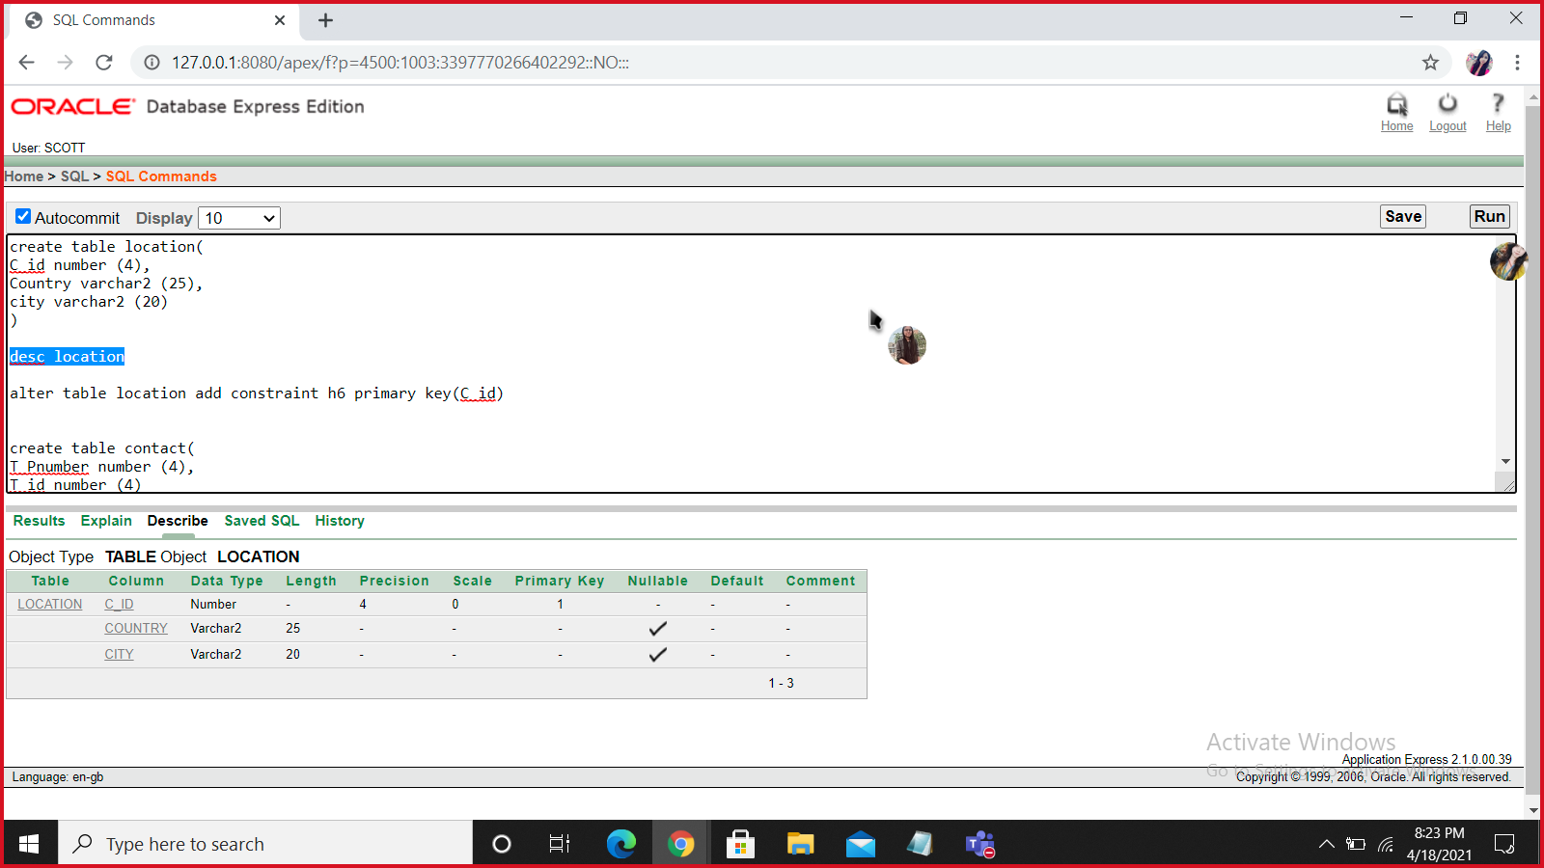

**CONTACT**

alter table contact add constraint jg9 primary key(T_id,T_Pnumber)

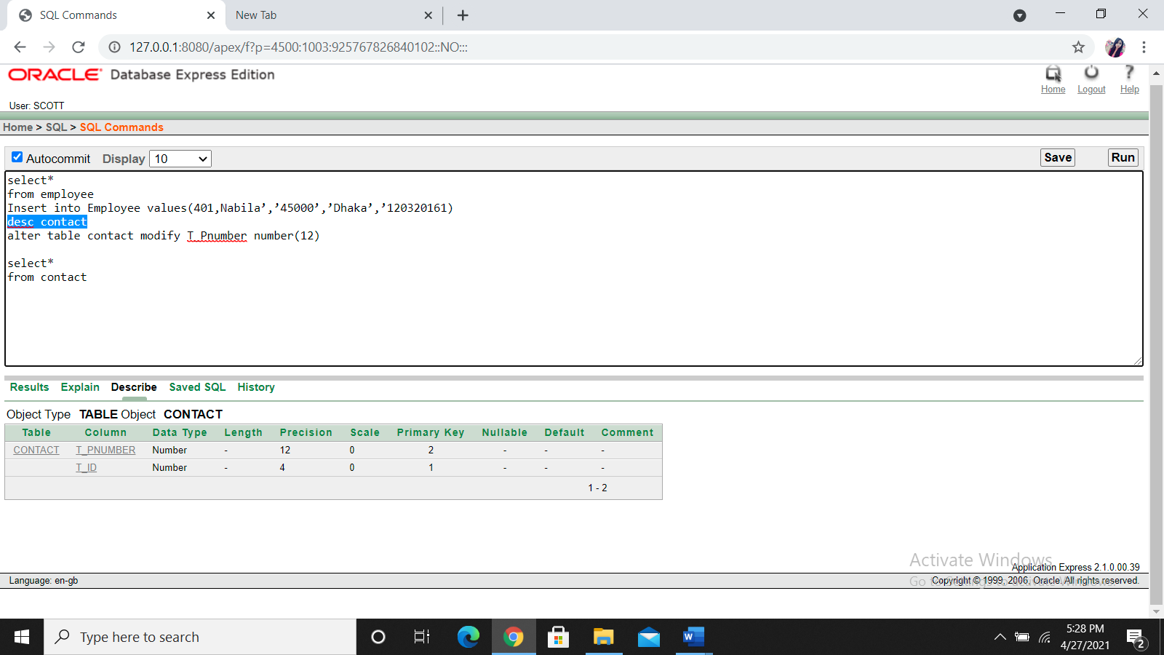

**NEW_TBL**

alter table new_tbl add constraint fg7 primary key(N_id)

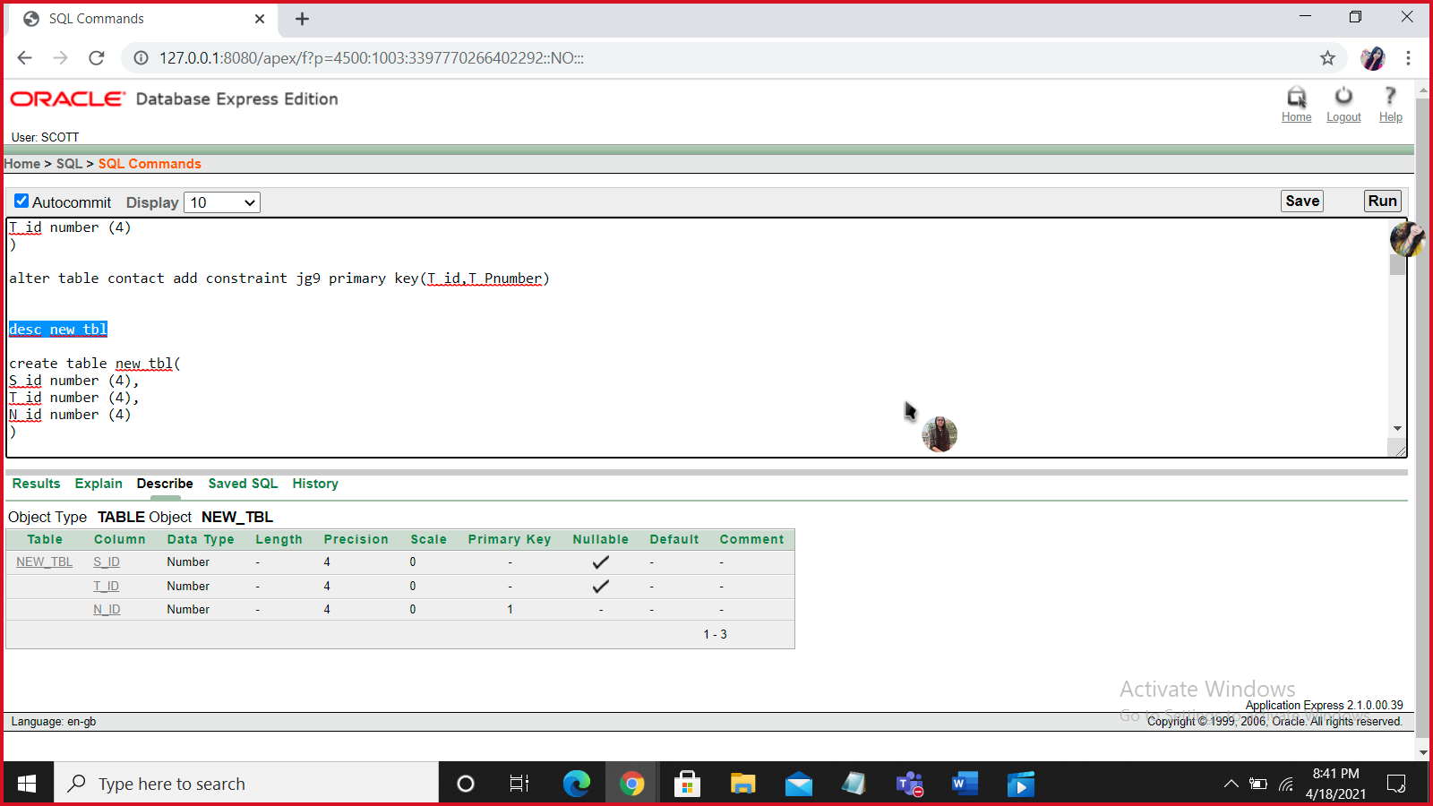

**TEACHER**

alter table Teacher add constraint df6 primary key(T_id)

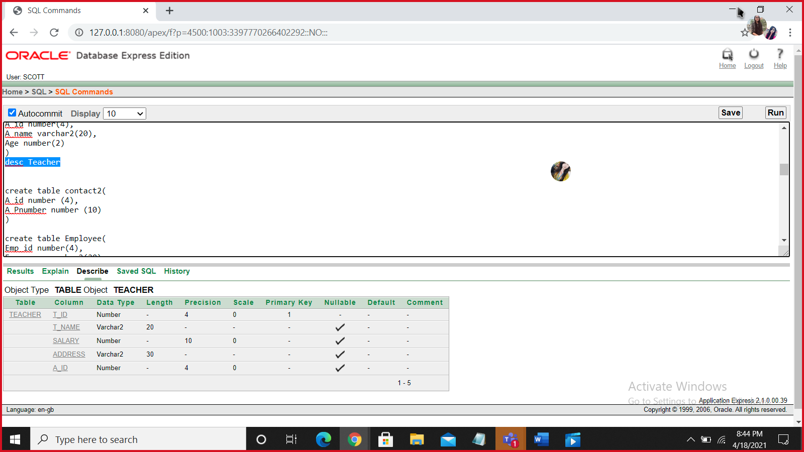

**ADMIN**

alter table Admin add constraint as4 primary key(A_id)

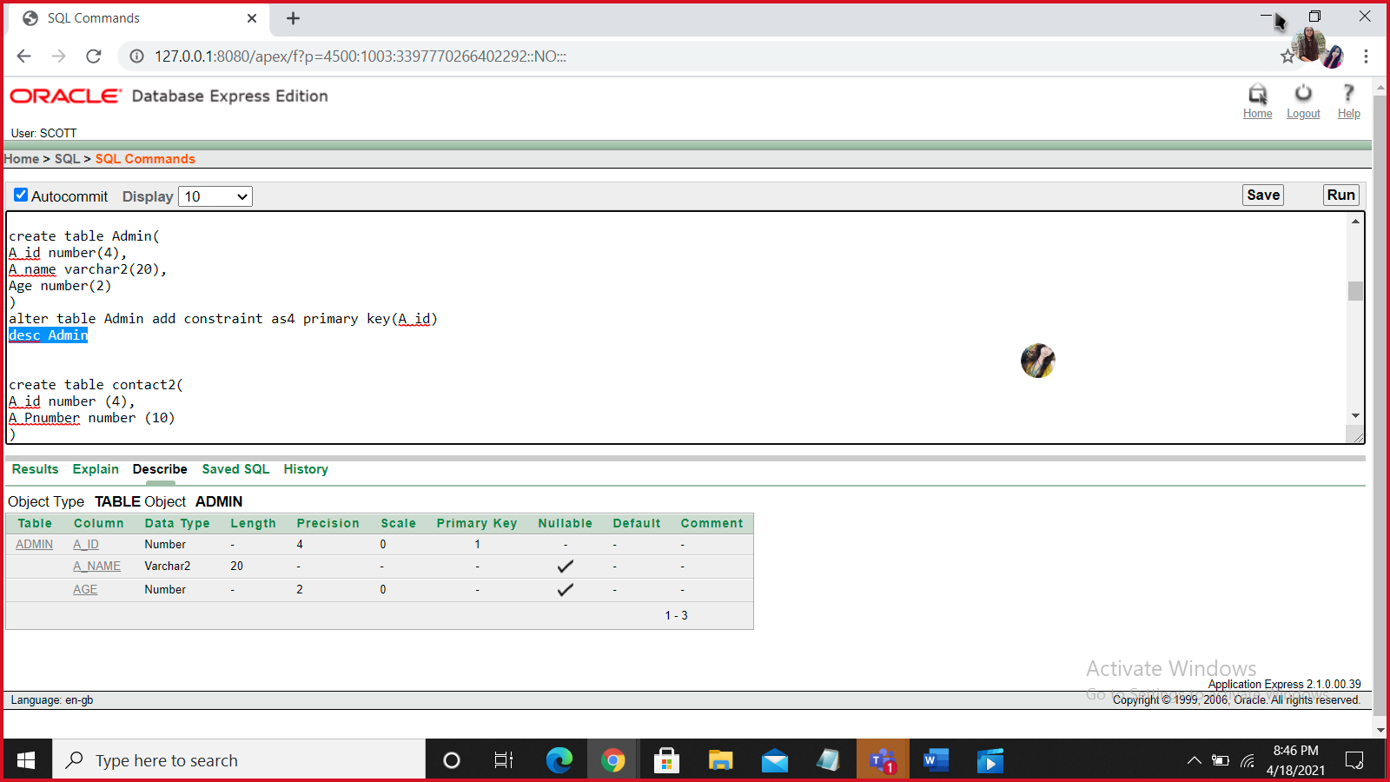

**CONTACT2**

alter table contact2 add constraint ui7 primary key(A_pnumber,A_id)

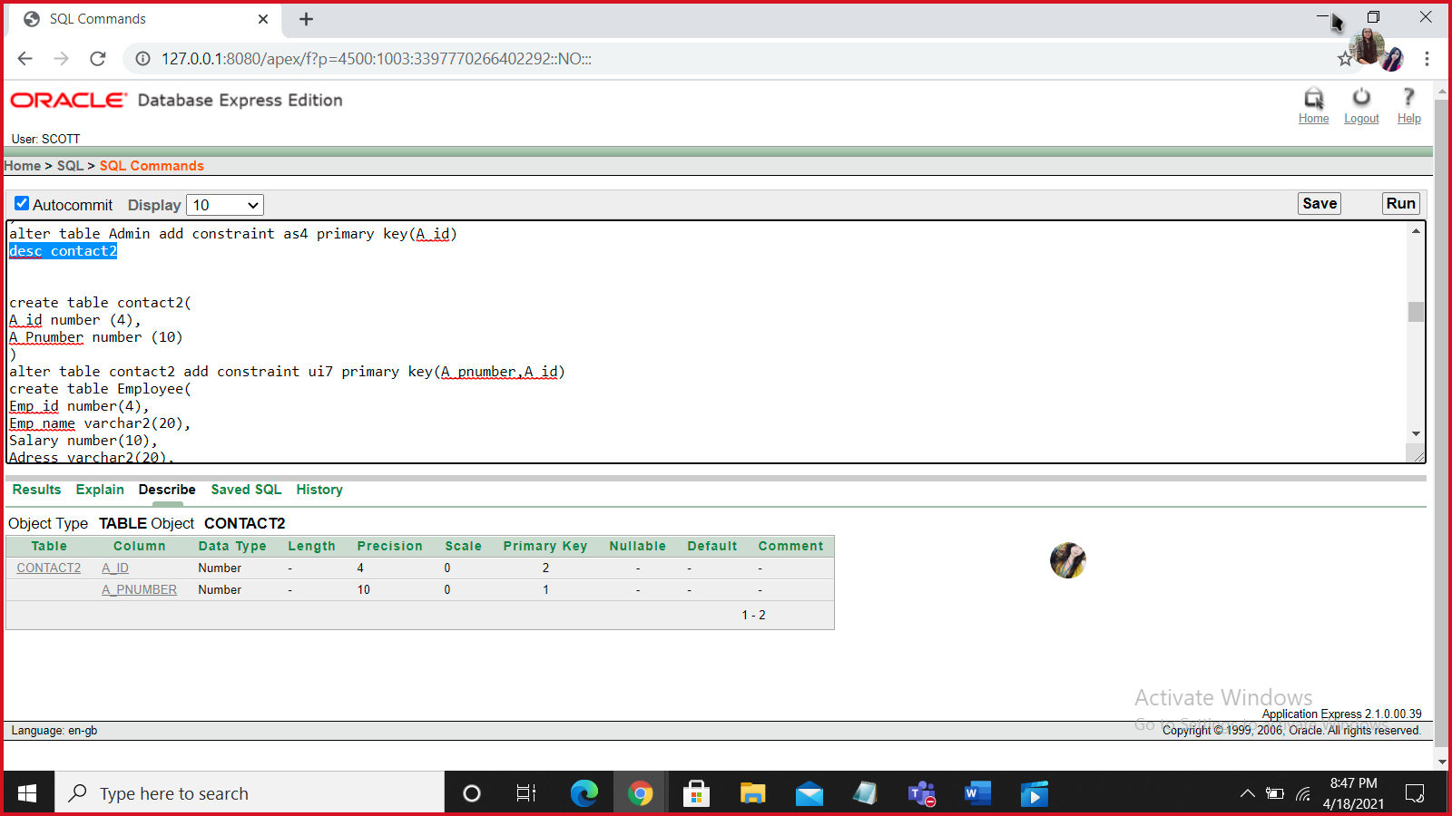

**EMPLOYEE**

alter table employee add constraint ew3 primary key(Emp_id)

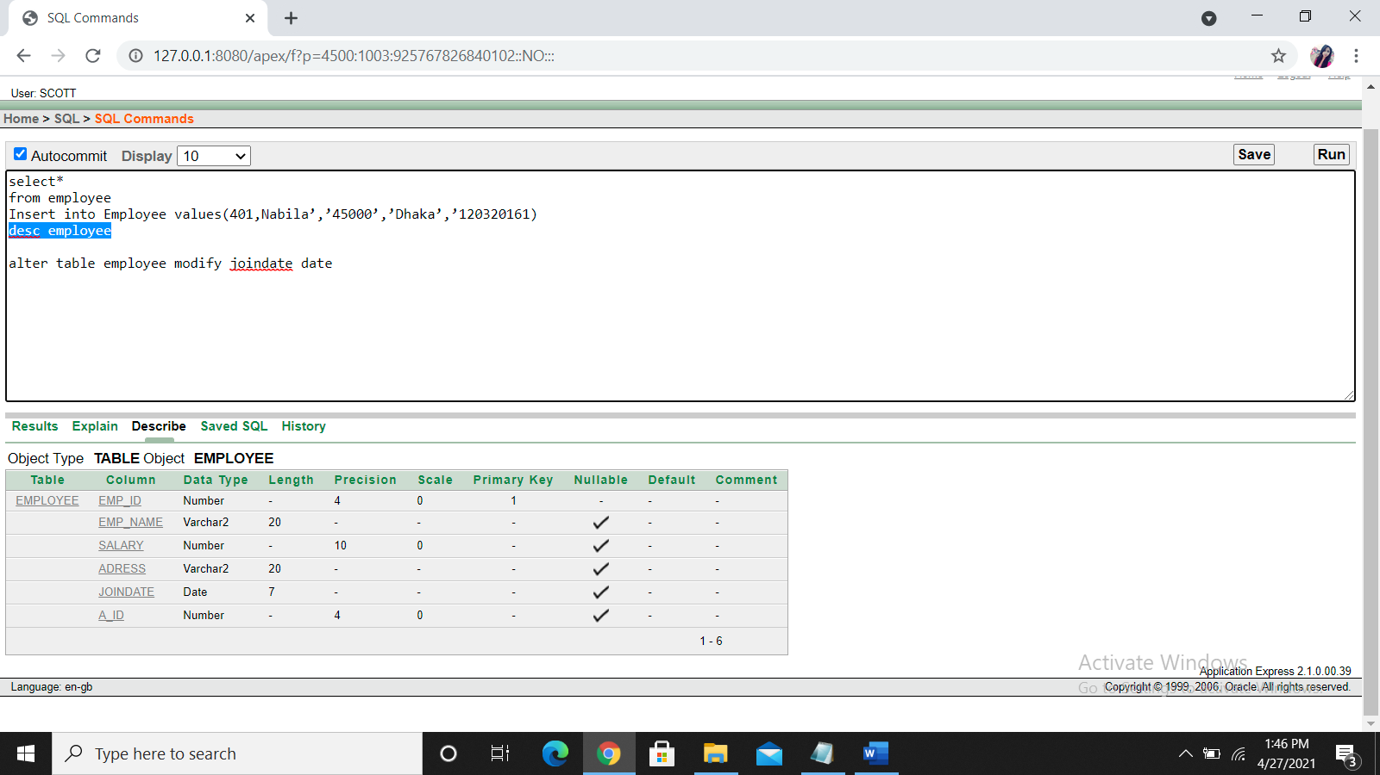

**STUDENT**

alter table student add constraint qe2 primary key(S_id)

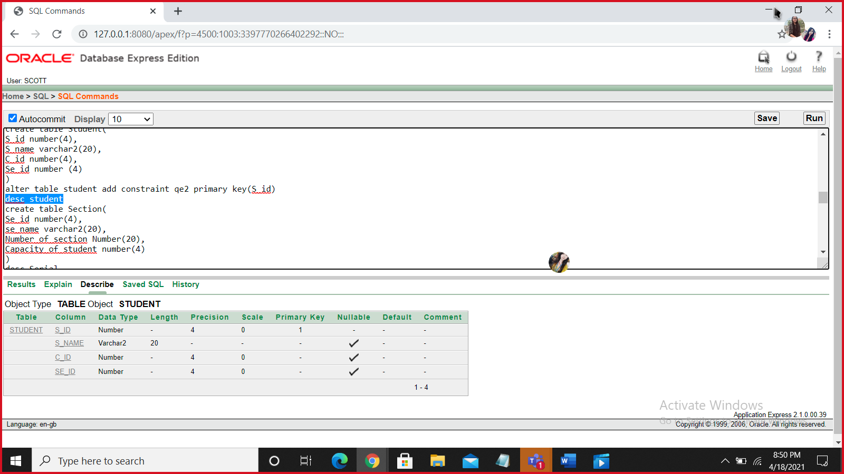

**SECTION**

alter table section add constraint ry7 primary key(Se_id)

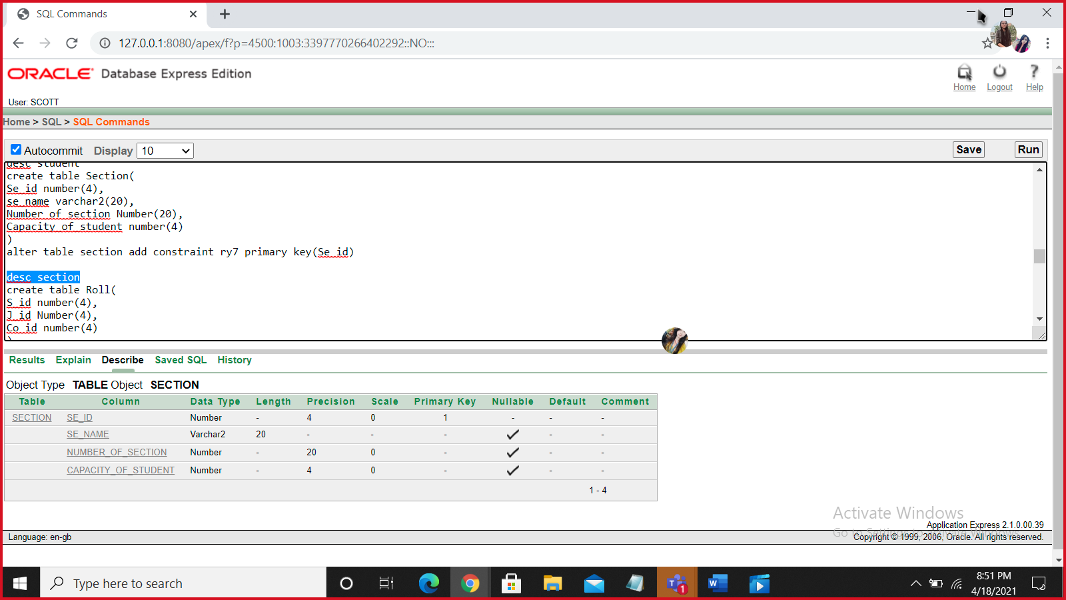

**ROLL**

alter table Roll add constraint gh9 primary key(J_id)

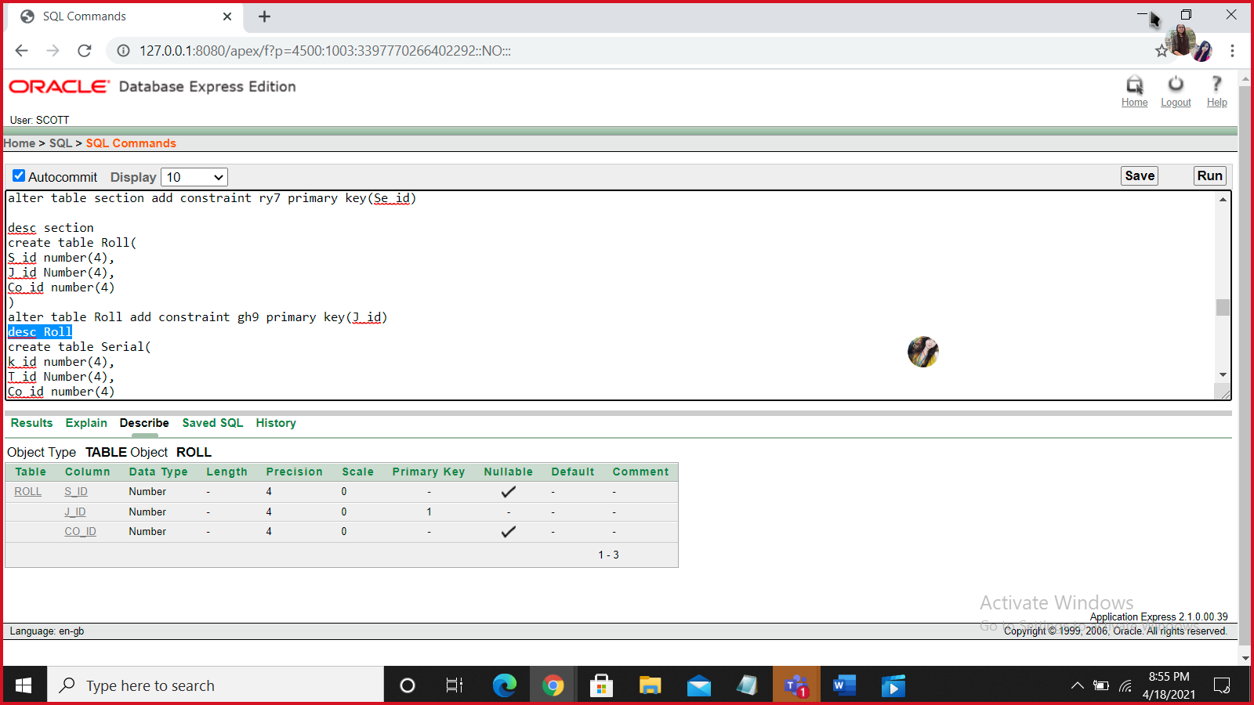

**SERIAL**

alter table Serial add constraint li8 primary key(K_id)

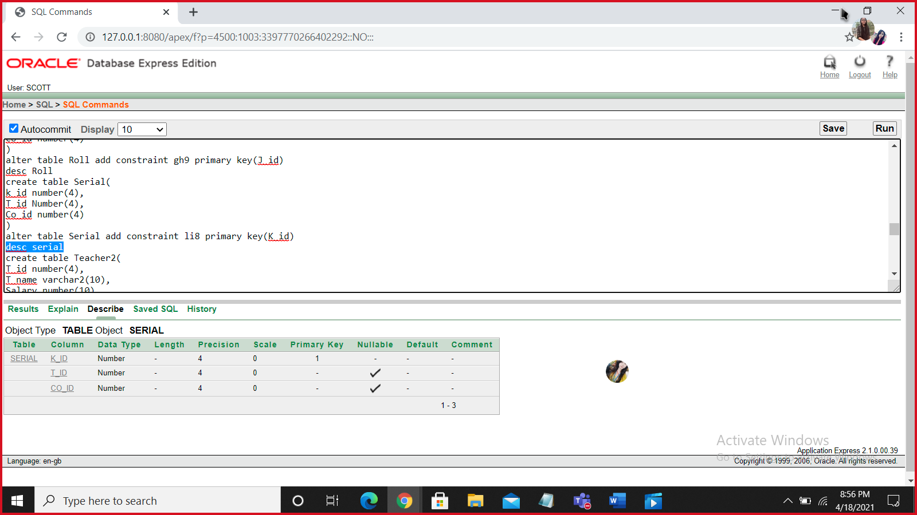

**TEACHER2**

alter table teacher2 add constraint lr2 primary key(T_id)

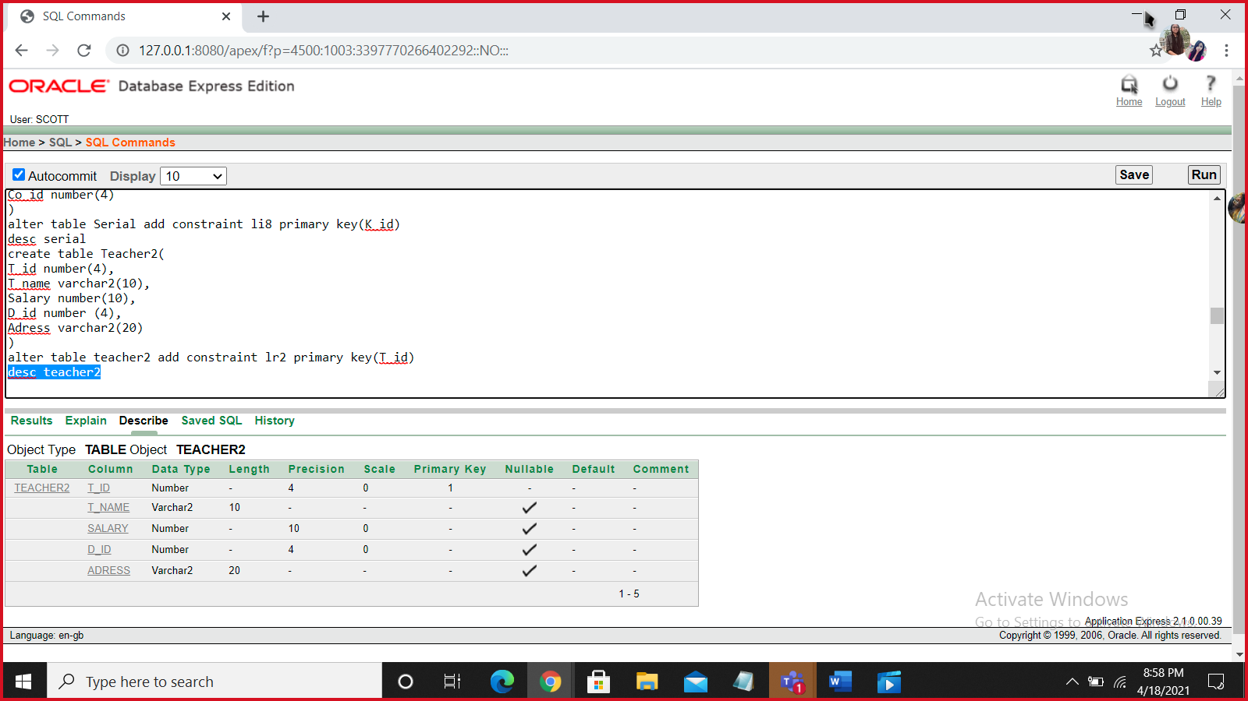

**COURSE**

alter table course add constraint jh1 primary key(Co_id)

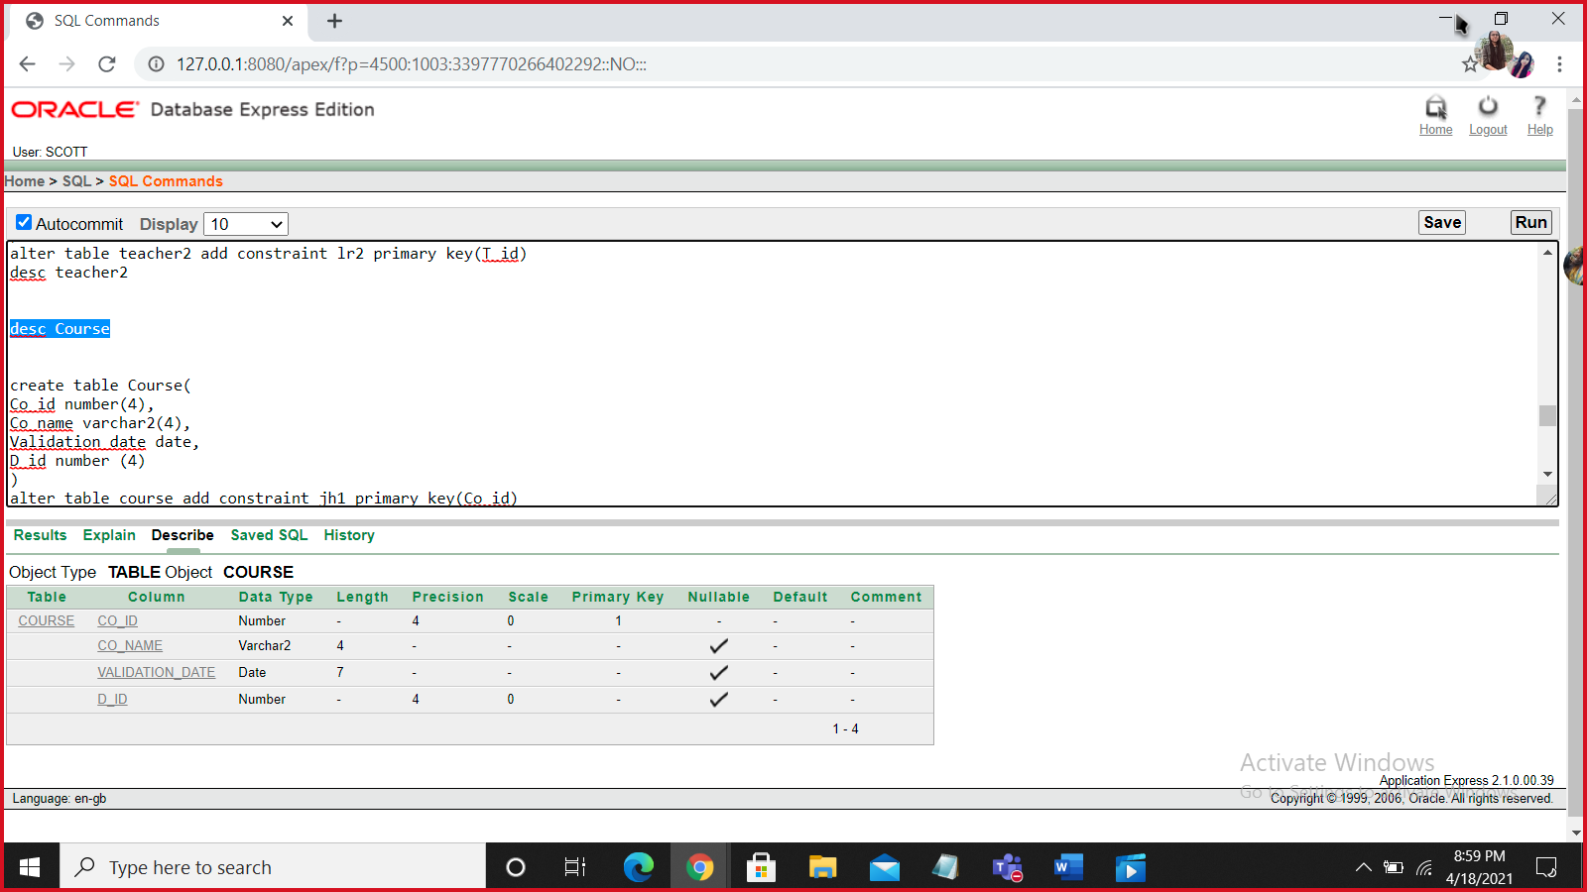

**DEPARTMENT**

alter table department add constraint mn8 primary key(D_id)

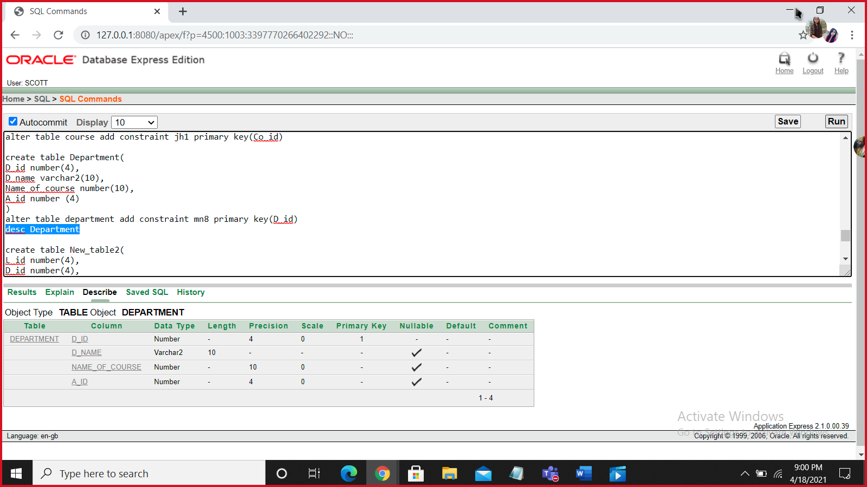

**NEW_TABLE2**

alter table new_table2 add constraint dg1 primary key(L_id)

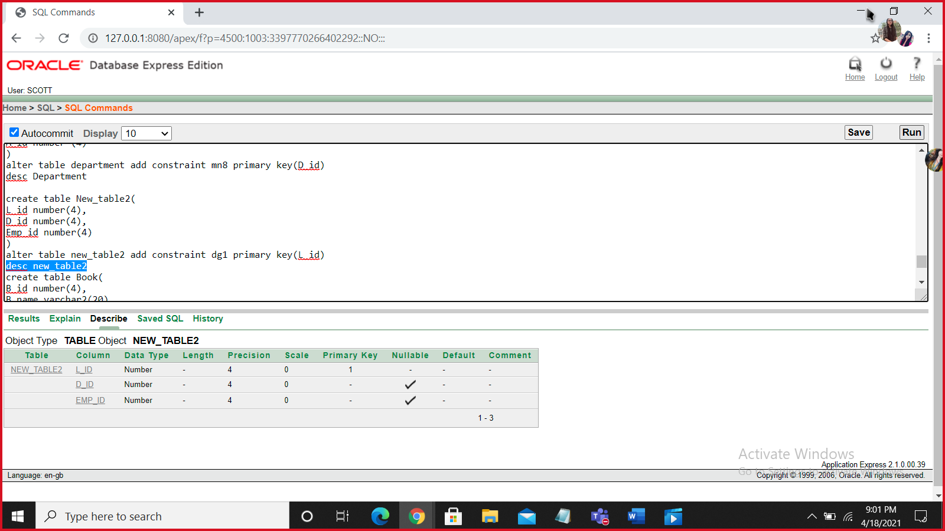

**BOOK**

alter table Book add constraint mo2 primary key(B_id)

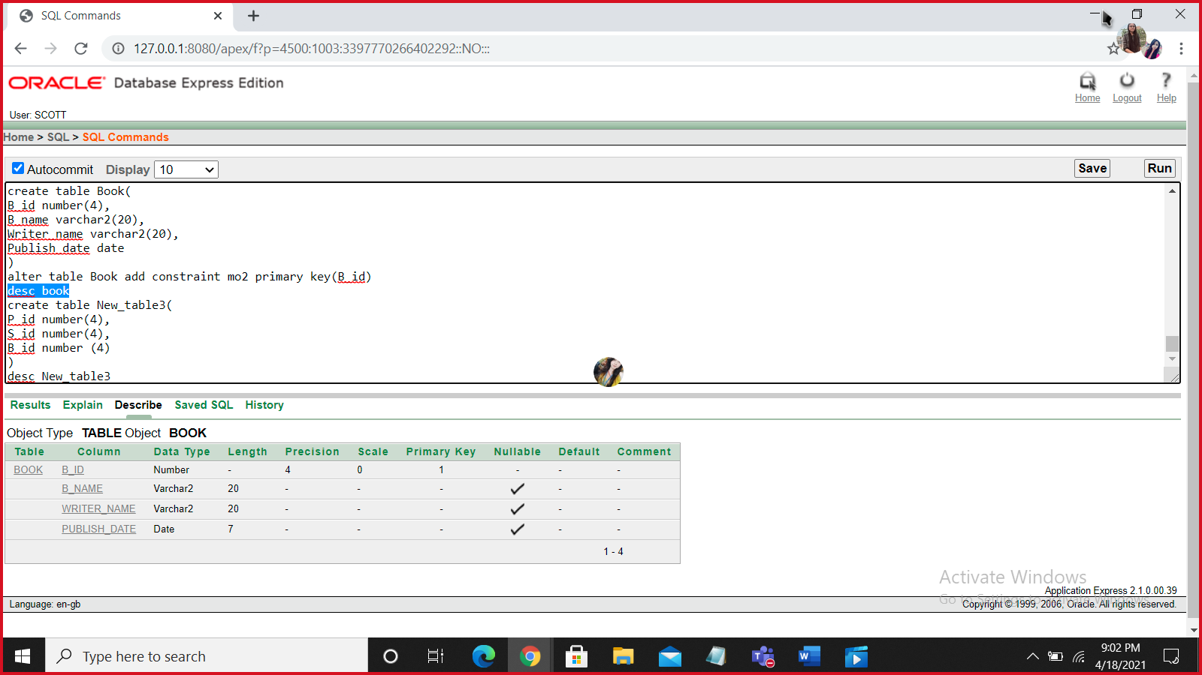

**NEW_TABLE3**

alter table new_table3 add constraint lm3 primary key(P_id)

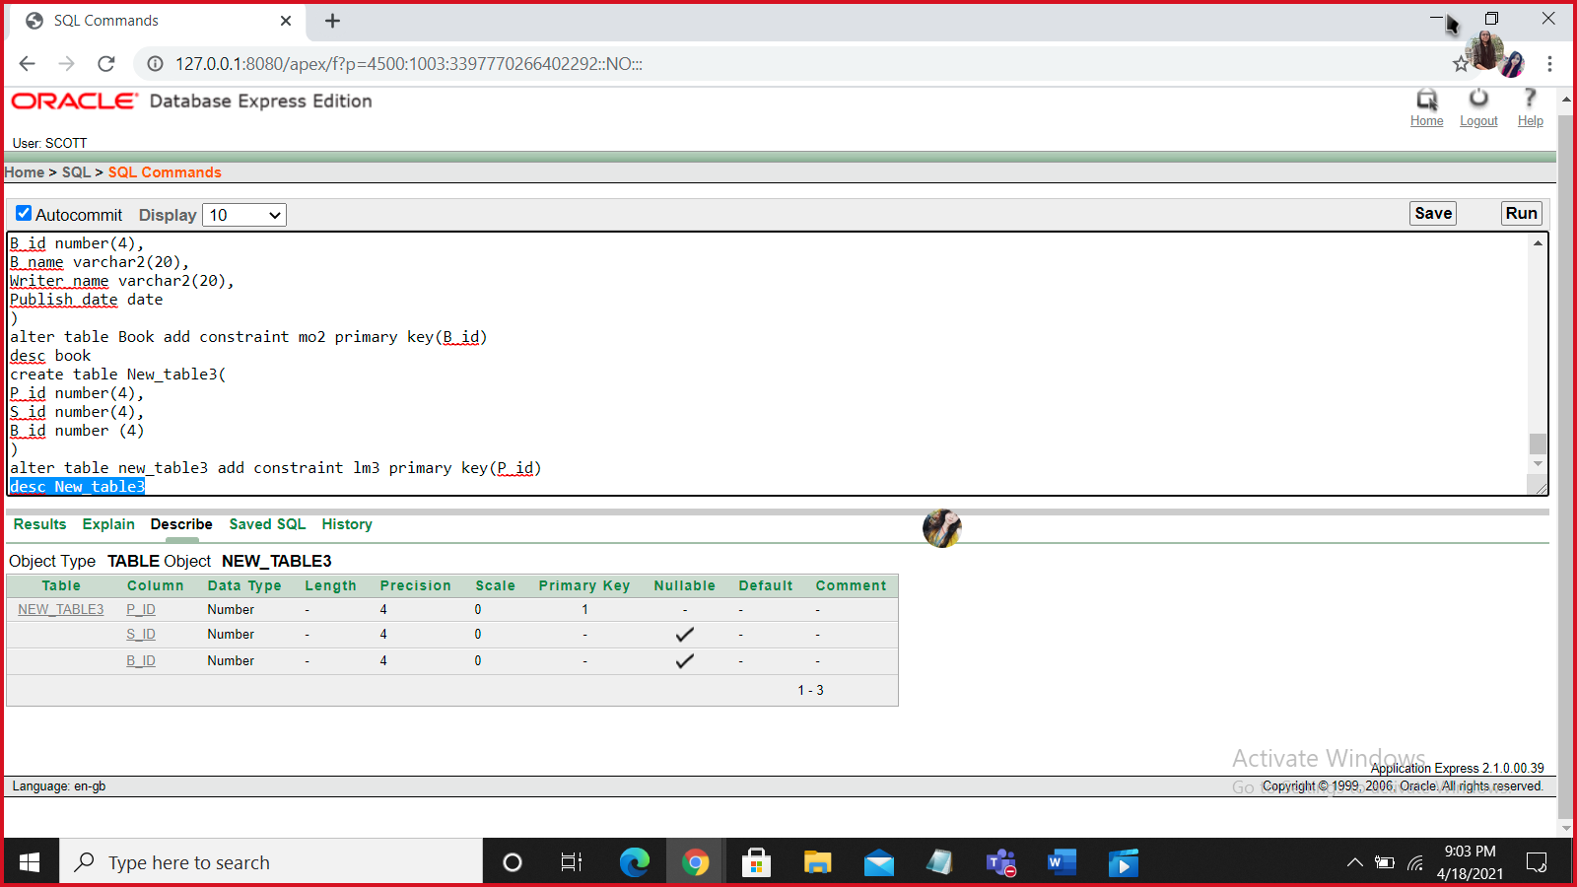

**foreign key**

alter table teacher add constraint drg foreign key (A_id) references admin(A_id)

desc teacher

alter table employee add constraint drf foreign key (A_id) references admin(A_id)

desc employee

alter table student add constraint pty foreign key (C_id) references location(C_id)

alter table student add constraint lkj foreign key (Se_id) references section(Se_id)

desc student

alter table roll add constraint plk foreign key (S_id) references student(S_id)

alter table roll add constraint mjk foreign key (Co_id) references course (Co_id)

desc roll

alter table serial add constraint klf foreign key (T_id) references teacher(T_id)

alter table serial add constraint vbh foreign key (Co_id) references course(Co_id)

desc serial

alter table teacher2 add constraint mfg foreign key (D_id) references department(D_id)

desc teacher2

alter table course add constraint pli foreign key (D_id) references department(D_id)

desc course

alter table department add constraint mkj foreign key (A_id) references admin(A_id)

desc department

alter table new_table2 add constraint dhj foreign key (D_id) references department(D_id)

alter table new_table2 add constraint cfg foreign key (Emp_id) references employee(Emp_id)

desc new_table2

alter table new_table3 add constraint l6j foreign key (S_id) references student(S_id)

alter table new_table3 add constraint kdo foreign key (B_id) references book(B_id)

desc new_table3

**VALUE INSERT**

**Location**

Insert into Location values(501,'Bangladesh','Dhaka')

Insert into Location values(502,'India','kolkata')

Insert into Location values(503,'England','london')

Insert into Location values(504,'Bangladesh','Khulna')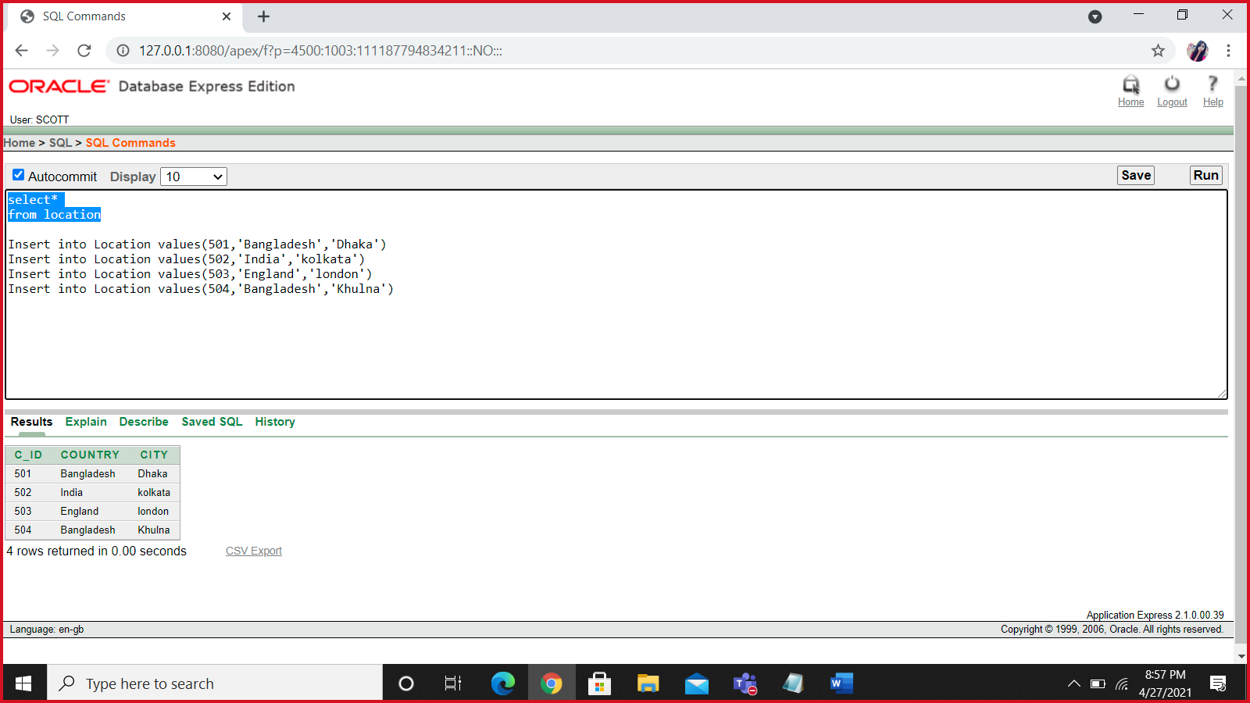

**admin**

Insert into Admin values(601,’Rafiq’,42)

Insert into Admin values(602,’ditu’,22)

Insert into Admin values(603,’sunny’,31)

Insert into Admin values(604,’rajin’,35)

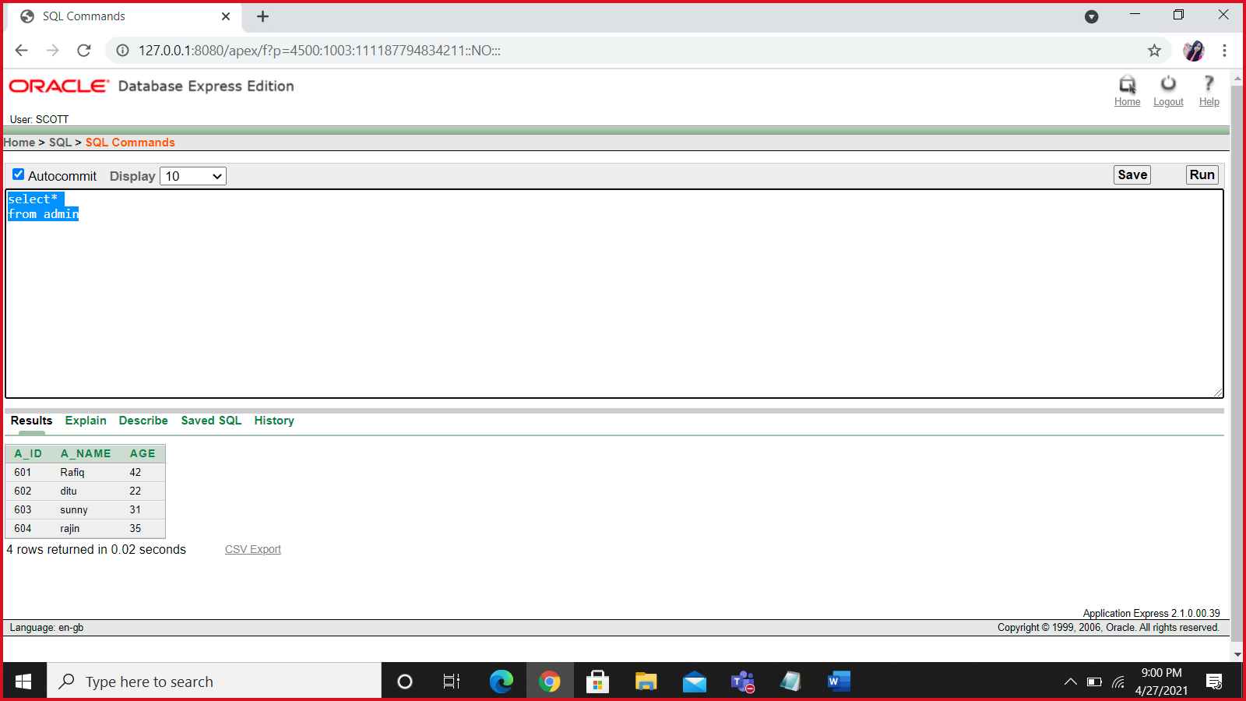

**Teacher**

Insert into Teacher values(201,'Farhana',55000,'dhaka',601)

Insert into Teacher values(202,'Rifat',60000,'dinajpur',602)

Insert into Teacher values(203,'sakila',50000,'barisal',603)

Insert into Teacher values(204,'jibonto',50000,'khulna',604)

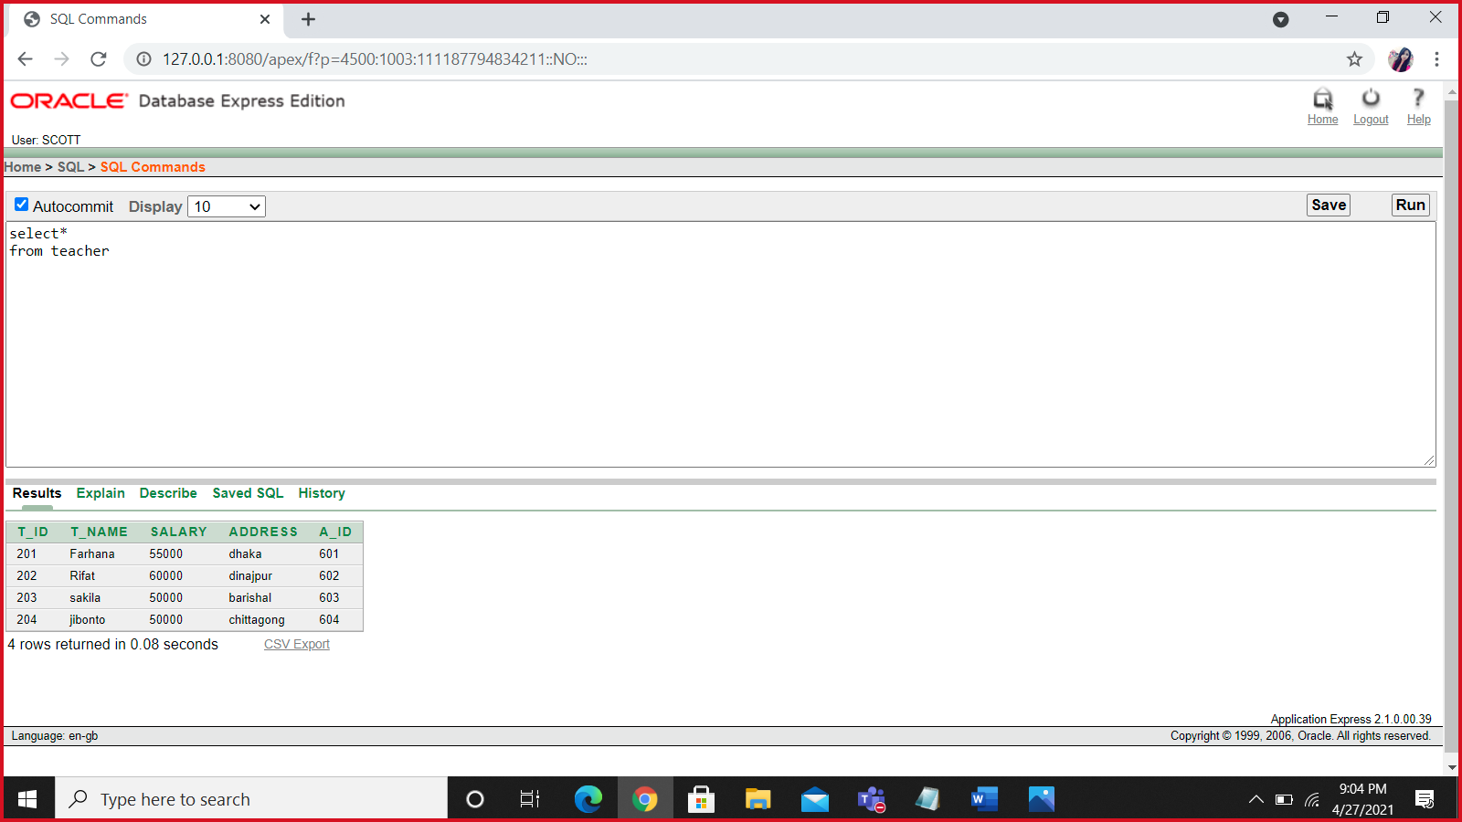

**Contact**

Insert into Contact values(‘017111111’,201)

Insert into Contact values(’017111112’,201)

Insert into Contact values(‘017111113’,202)

Insert into Contact values(‘017111114’,202)

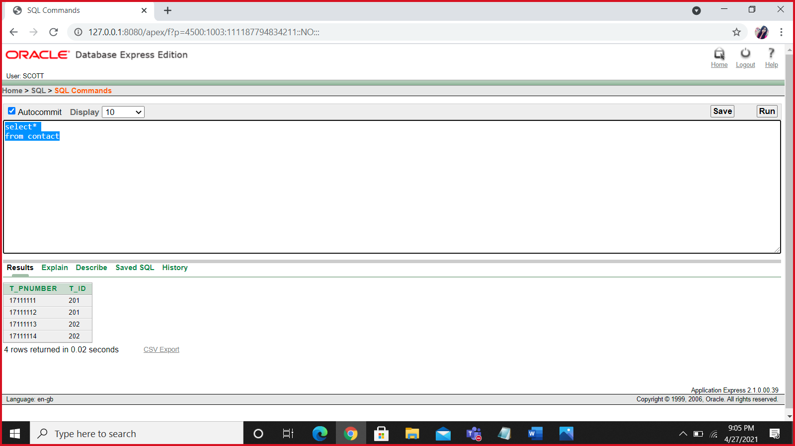

**Contact2**

Insert into Contact2 values(601,0117111115)

Insert into Contact2 values(601,017111116)

Insert into Contact2 values(602,017111117)

Insert into Contact2 values(602,017111118)

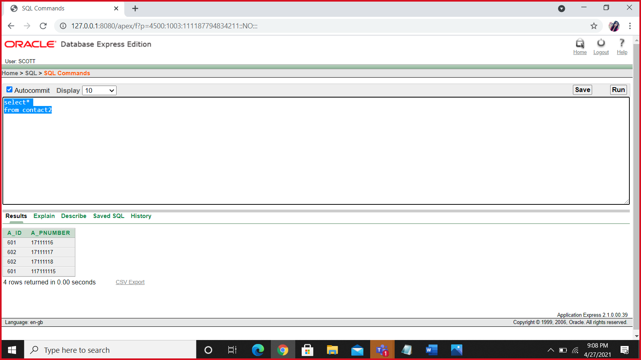

**Employee**

insert into Employee values(401,'Nabila',45000,'Dhaka','12-jan-16',601)

insert into Employee values(402,'kamiya',45000,'Dhaka','14-may-15',602)

insert into Employee values(403,'jijon',45000,'Rajsahi','20-dec-09',603)

insert into Employee values(404,'Antu',45000,'khulna','19-feb-16',604)

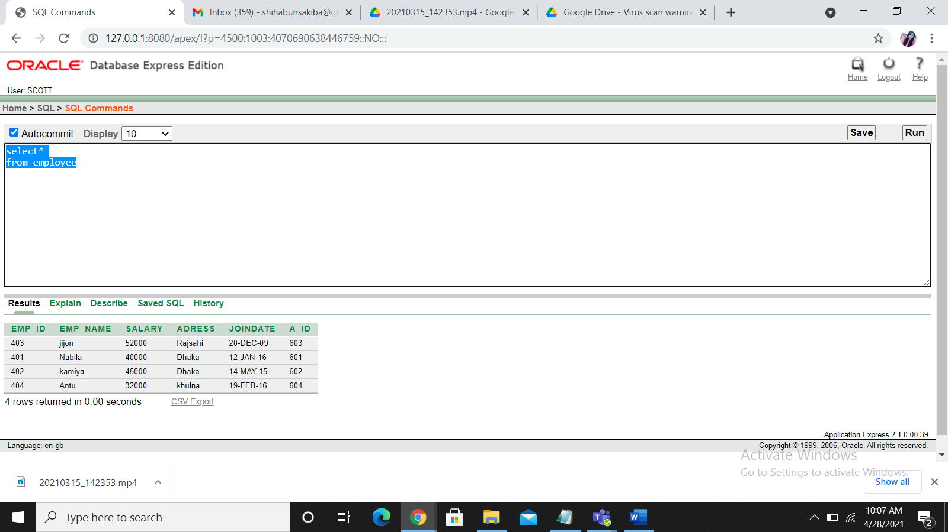

**Section**

insert into Section values(701,'b3',10,45)

insert into Section values(702,'b4',10,45)

insert into Section values(703,'B5',10,45)

insert into Section values(704,'B6',10,45)

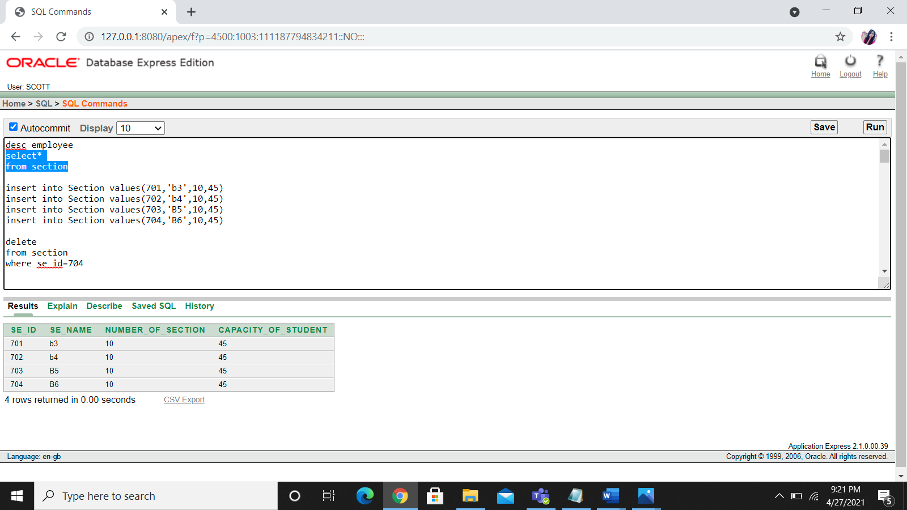

**student**

insert into Student values(101,'Shihabun',501,701)

insert into Student values(102,'Snahasish',502,702)

insert into Student values(103,'Bushra',503,703)

insert into Student values(104,'Badhon',504,704)

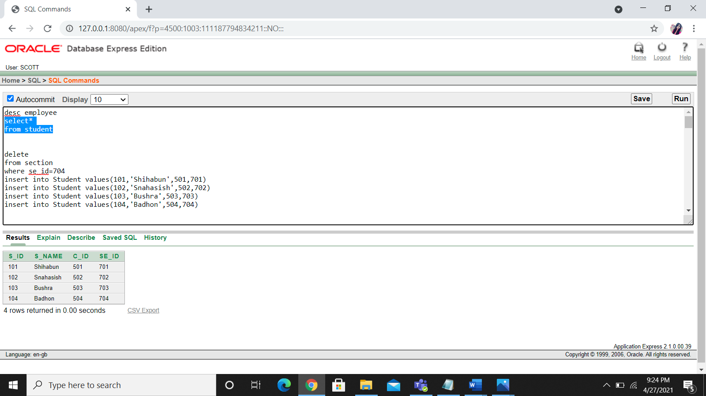

**DEPARTMENT**

insert into Department values(301,'CSE',15,601)

insert into Department values(302,'EEE',12,602)

insert into Department values(303,'BBA',17,603)

insert into Department values(304,'LAW',09,604)

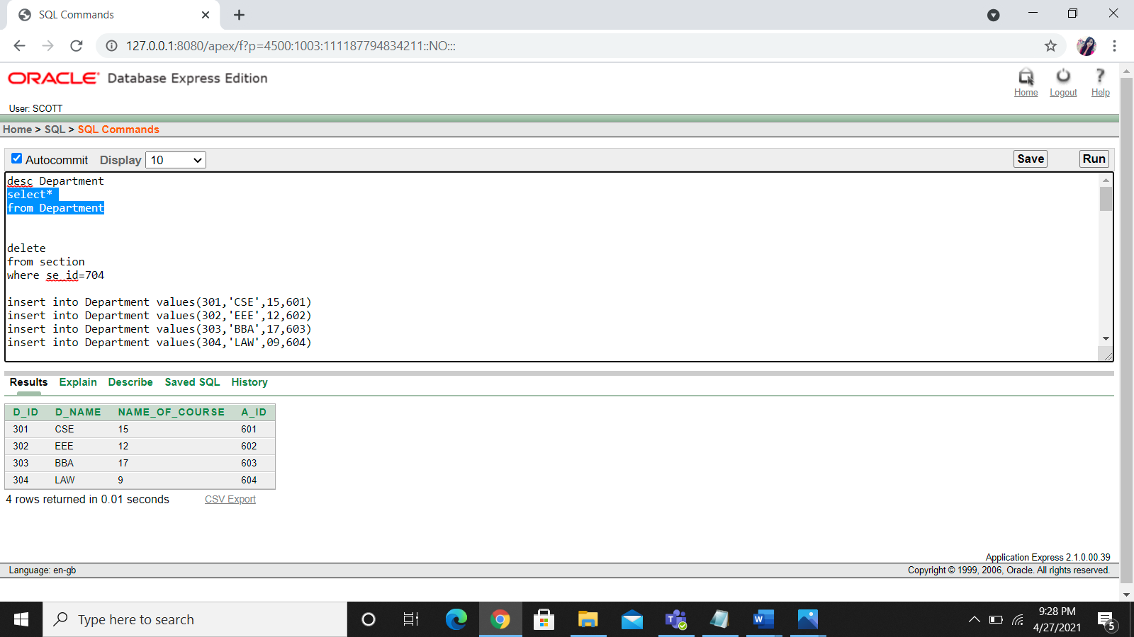

**Teacher2**

insert into Teacher2 values(201,'Farhana',55000,301,'Dhaka')

insert into Teacher2 values(202,'Sneha',120000,302,'Chittagong')

insert into Teacher2 values(203,'Fahmida',100000,303,'Barisal')

insert into Teacher2 values(204,'Suborna',80000,304,'Khulna')

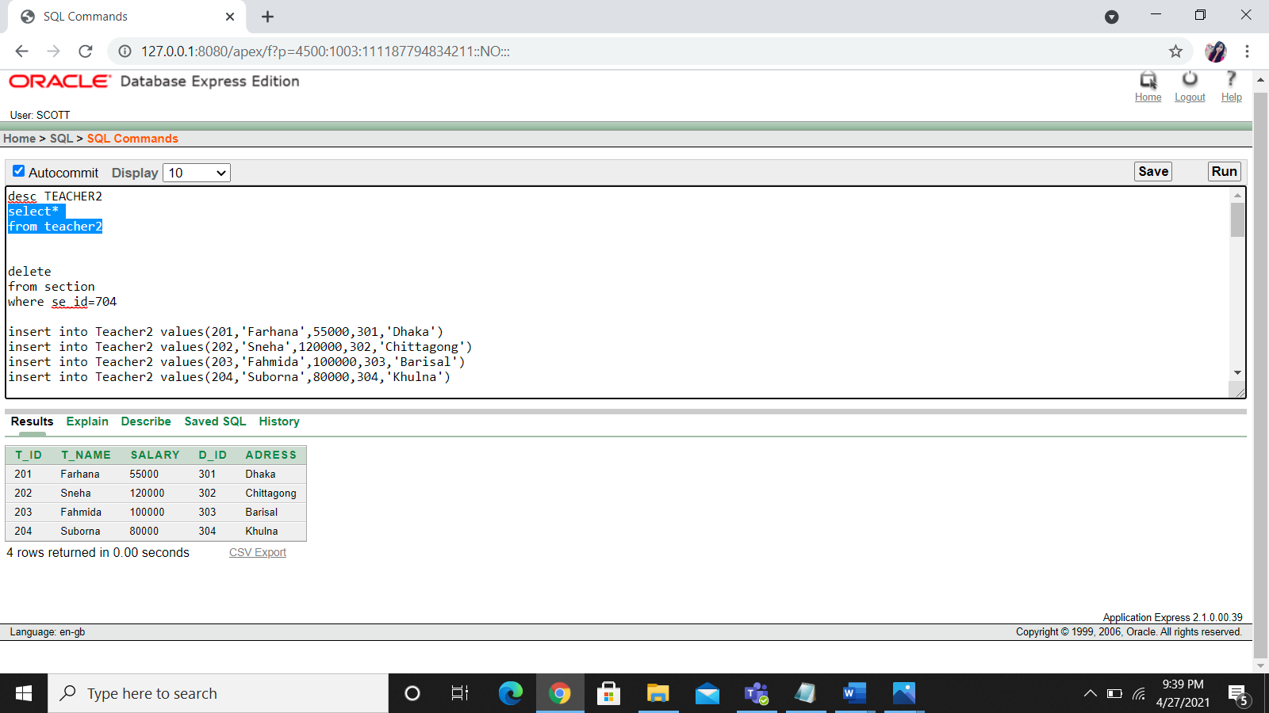

**course**

insert into Course values(801,'Java','25-jan-21',301)

insert into Course values(802,'ICS','11-may-21',302)

insert into Course values(803,'IEC','22-jun-21',303)

insert into Course values(804,'IPL','25-sep-21',304)

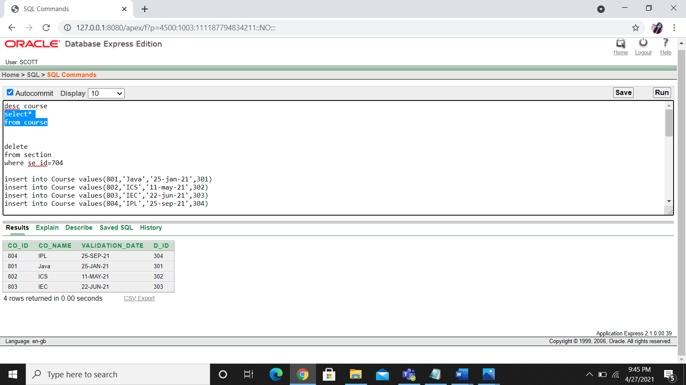

**Constraint used in this table**

**Book**

insert into Book values(901,'Physics1','Abdul_kader','20-jun-15')

insert into Book values(902,'Physics2','Abdul_kader','10-may-17')

insert into Book values(903,'Biology1','Haji_uddinj','11-aug-11')

insert into Book values(904,'Biology2','Kudre_muhammad','29-jul-14')

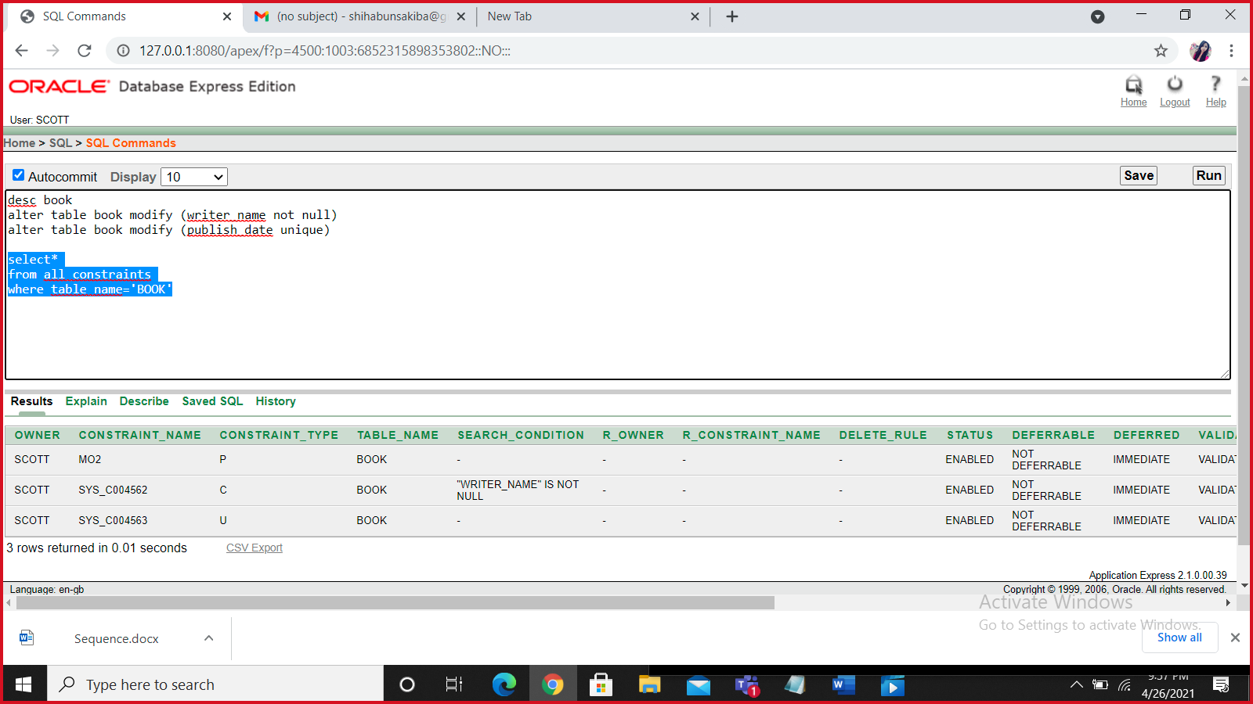

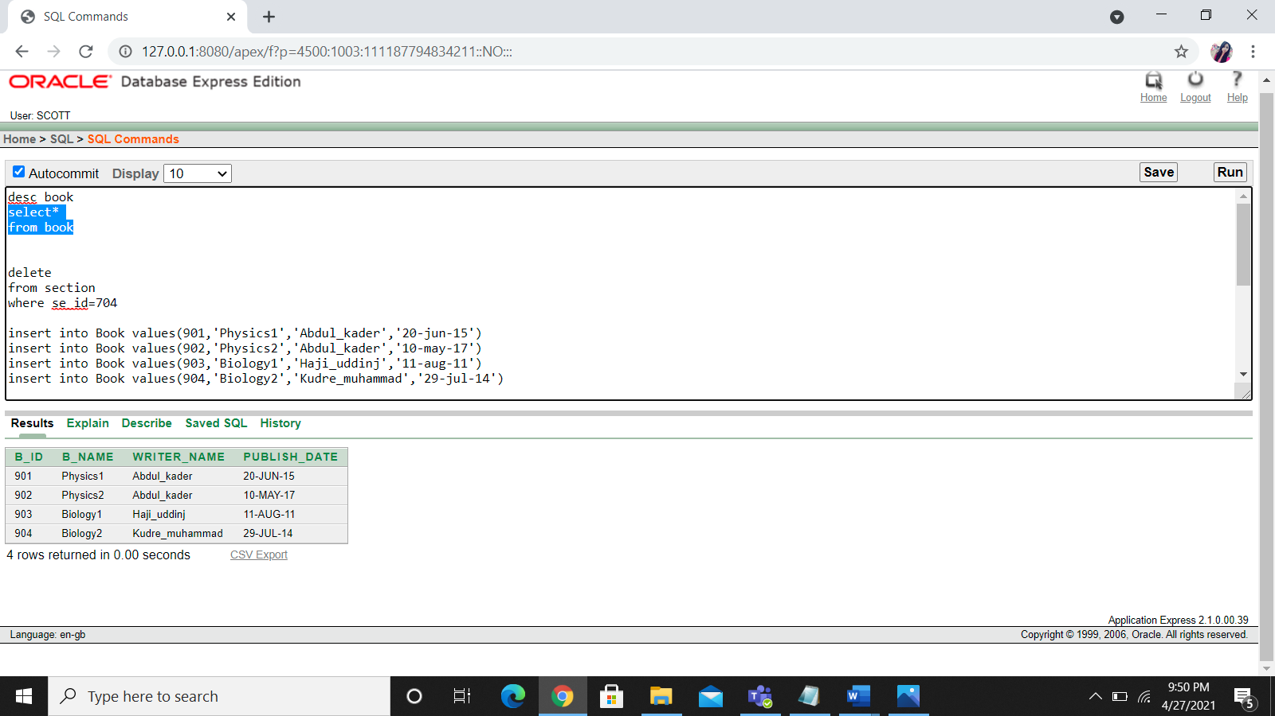

**roll**

Insert into Roll values(101,1001,801)

Insert into Roll values(102,1002,802)

Insert into Roll values(103,1003,803)

Insert into Roll values(104,1004,804)

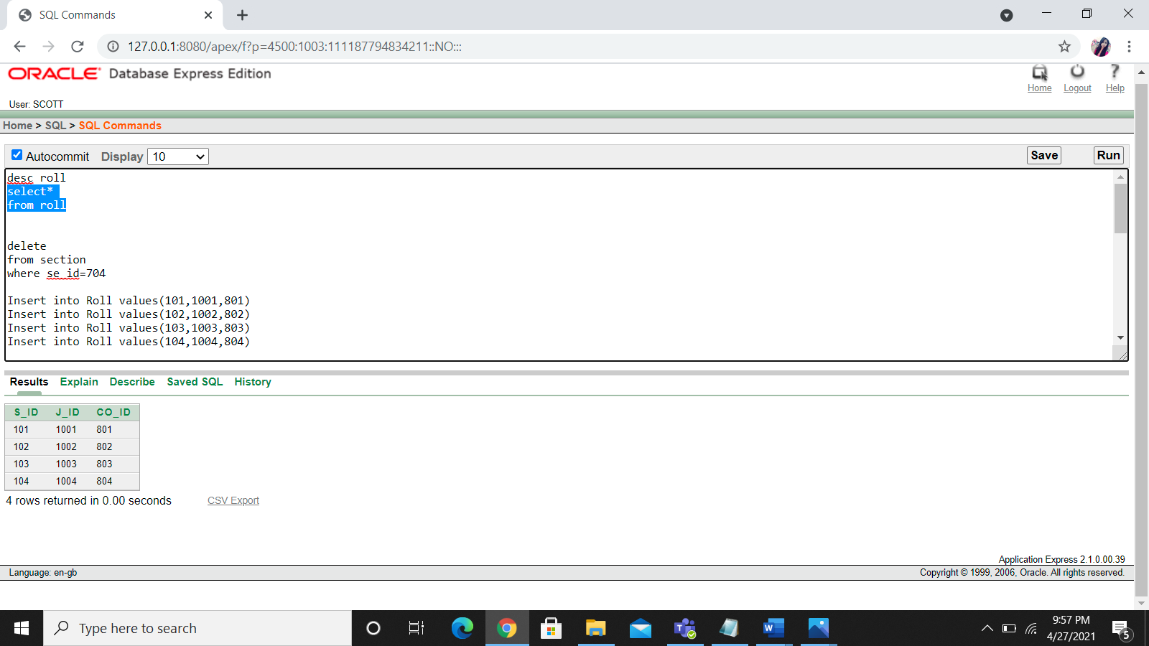

**Serial**

Insert into Serial values(1101,201,801)

Insert into Serial values(1102,202,802)

Insert into Serial values(1103,203,803)

Insert into Serial values(1104,204,804)

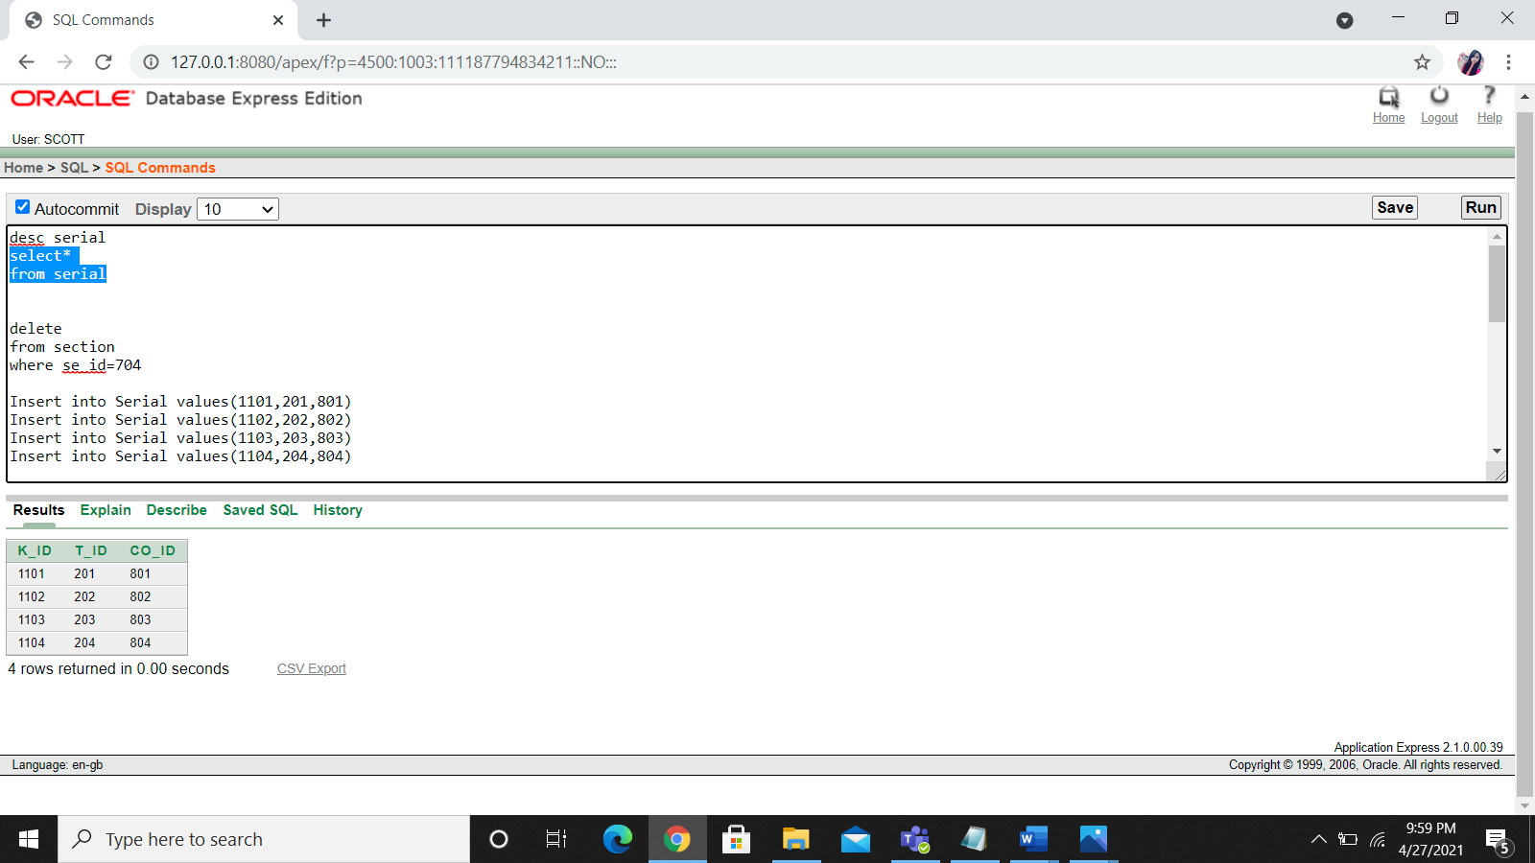

**New_table3**

Insert into New_table3 values(1401,101,901)

Insert into New_table3 values(1402,102,902)

Insert into New_table3 values(1403,103,903)

Insert into New_table3 values(1404,104,904)

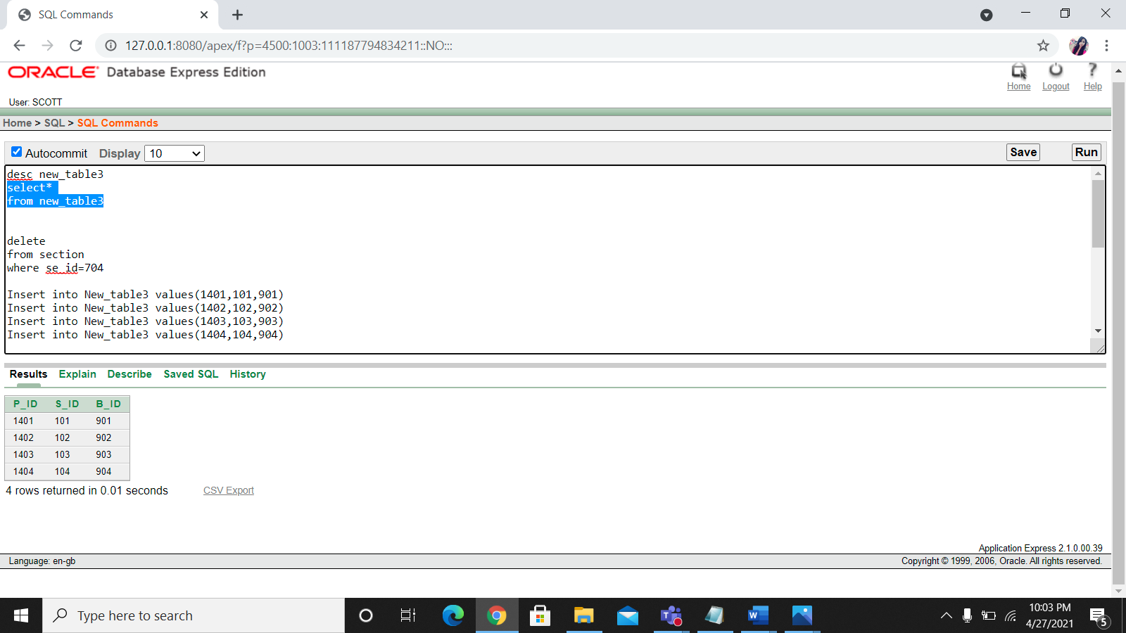

**Value insertion with sequence use**

**New_table**

create sequence new_tbl_seq

start with 50

increment by 2

maxvalue 80

nocycle

cache 10

insert into new_tbl (N_id,S_id,T_id) values(new_tbl_seq.nextval , 101 , 201)

insert into new_tbl (N_id,S_id,T_id) values(new_tbl_seq.nextval , 102 , 202)

insert into new_tbl (N_id,S_id,T_id) values(new_tbl_seq.nextval , 103 , 203)

insert into new_tbl (N_id,S_id,T_id) values(new_tbl_seq.nextval , 104 , 204)

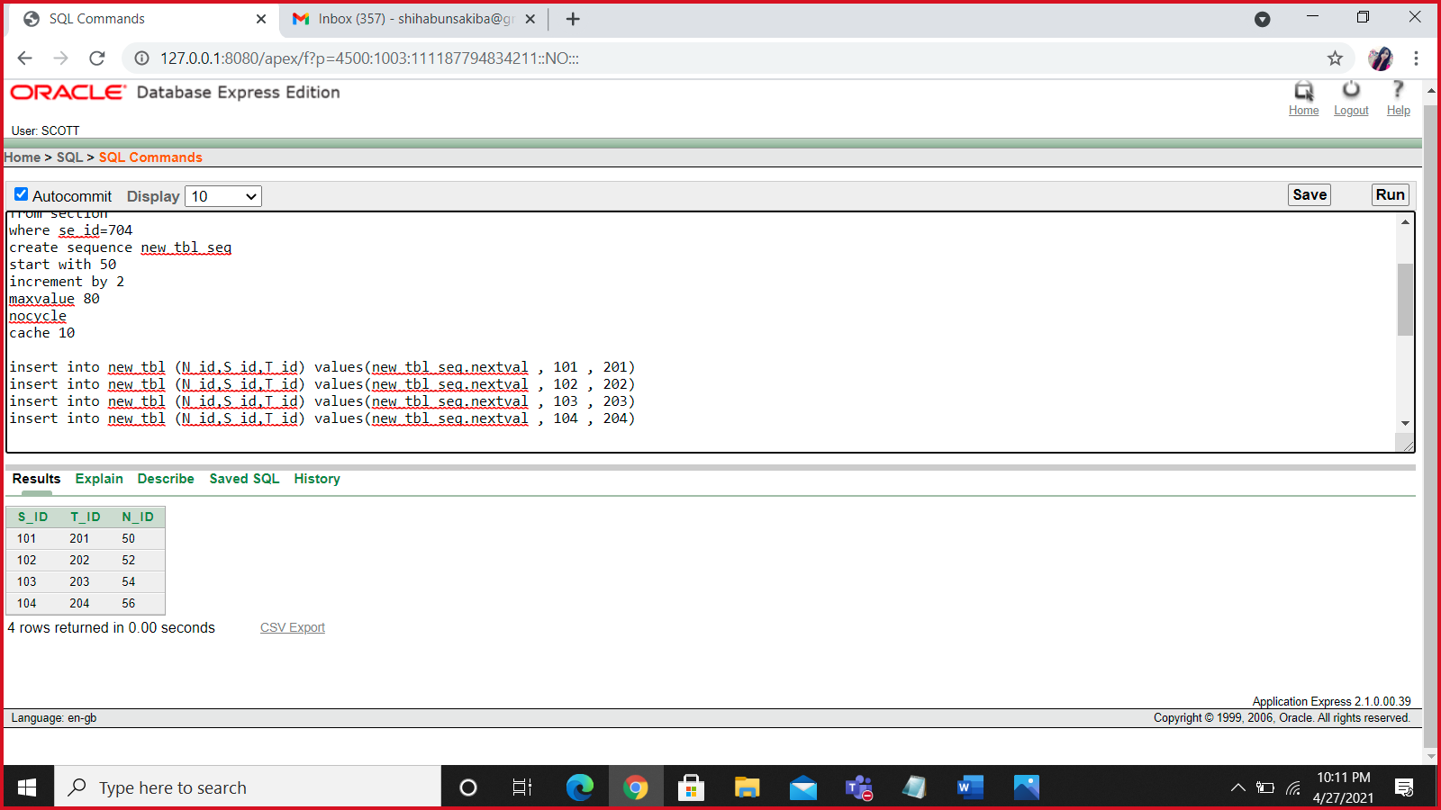

**New_table2**

create sequence new_tbl2_seq

start with 150

increment by 4

maxvalue 180

nocycle

cache 10

insert into new_table2 (L_id,D_id,Emp_id) values(new_tbl2_seq.nextval , 301, 401)

insert into new_table2 (L_id,D_id,Emp_id) values(new_tbl2_seq.nextval , 302, 402)

insert into new_table2 (L_id,D_id,Emp_id) values(new_tbl2_seq.nextval , 303, 403)

insert into new_table2 (L_id,D_id,Emp_id) values(new_tbl2_seq.nextval , 304, 404)

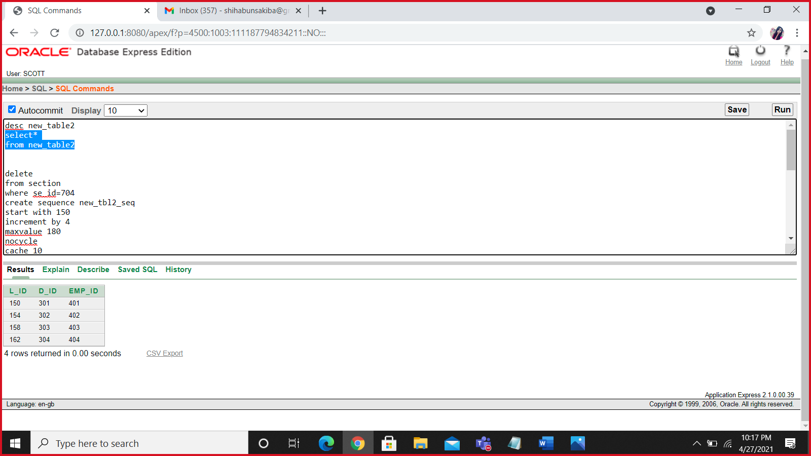

**QUERY WRITING**

1.Display the teacher name,address and salary of all teachers whose salary is equal to the minimum salary

2. Display salary and name whose Salary is less or equal to the salary of employee id 403

3. Display employee names who joined on 14th February 2015

4. Write a query to display the name, department number, and department name for  
all employees.

5.Find average, maximum, minimum & summation salary of the employees. Label the columns Maximum, Minimum, Sum, and Average, respectively

6. Find the number of employee who have salary >32000

7. create a view called student *view base on the S*id,S_name,c_id,Se_id

8. show the information of all employee like " Nabila lives Dhaka"

9. write a query for S_ID,S_ID,s_name for student and roll

10. create a view called Admin _*view base on the a_*id,a_name,age